Manual MPGuino
T vago version

settings
Metric system | US system
LCD Contrast
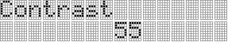
Description

Display Mode
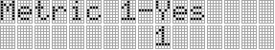 | 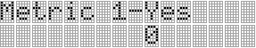
Description | Description
Fuel Injector Edge Trigger
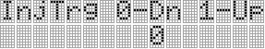
Description

Fuel System Pressure
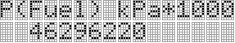 | 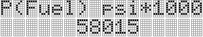
Description | Description
Reference Fuel Injector Rated Pressure
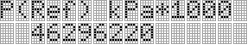 | 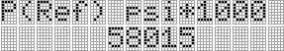
Description | Description
Fuel Injector Count
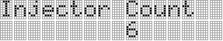
Description

Fuel Injector Rated Capacity
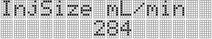
Description

Microseconds per gal or L
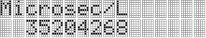 | 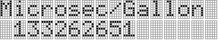
Description | Description
Fuel Injector Response Delay Time
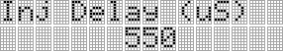
Description

VSS Pulses per mile or per km
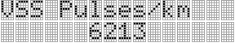 | 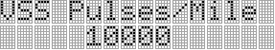
Description | Description
VSS Pause Debounce Count
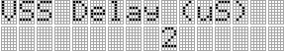
Description

Crankshaft Revolutions per Fuel Injector Event
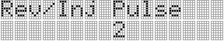
Description

Minimum Engine Speed For Engine On RPM
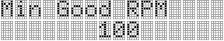
Description

Tank Capacity
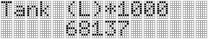 | 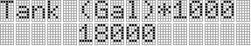
Description | Description
MAP Sensor Floor * 1000 (mV)
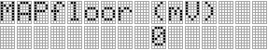
Description

Barometric Sensor Floor * 1000 (mV)
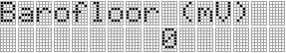
Description

MAP Sensor Ceiling * 1000 (mV)
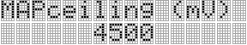
Description

Barometric Sensor Ceiling * 1000 (mV)
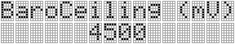
Description

MAP Sensor Range * 1000 (psig or kPa)
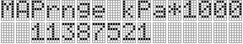 | 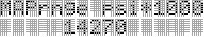
Description | Description
Barometric Sensor Range * 1000 (psig or kPa)
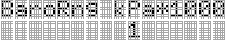 | 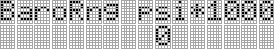
Description | Description
MAP Sensor Offset * 1000 (psig or kPa)
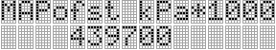 | 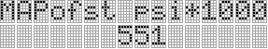
Description | Description
Barometric Sensor Offset * 1000 (psig or kPa)
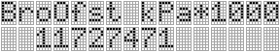 | 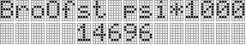
Description | Description
Vehicle Weight/Mass (lbs or kg)
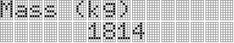 | 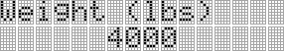
Description | Description
Vehicle Frontal Area * 1000 (ft^2 or m^2)
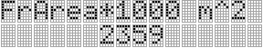 | 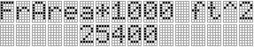
Description | Description
Air density (lb/yd^3 or kg/m^3)
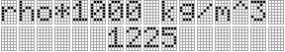 | 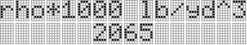
Description | Description
Vehicle C(d) * 1000
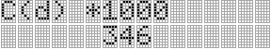
Description

Vehicle C(v) * 1000
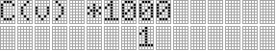
Description

Vehicle C(rr) * 1000
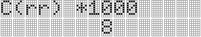
Description

Activity Timeout
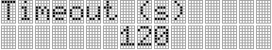
Description

Enable current trip reset upon wakeup
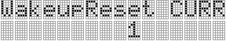
Description

Serial Data Logging Enable
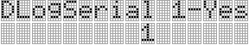
Description

Window Filter Enable
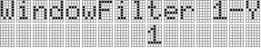
Description

Period Of FE over Time BarGraph Bar (s)
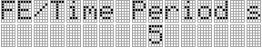
Description

Autosave Active Trip Data Enable
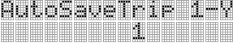
Description

Autosave Idle Trip Data Enable
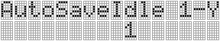
Description

FE vs Speed Bargraph lower speed
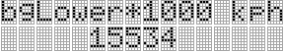 | 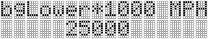
Description | Description
FE vs Speed Bargraph speed bar size
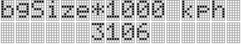 | 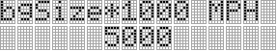
Description | Description
Price per unit volume of fuel
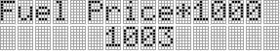
Description

Scratchpad Memory
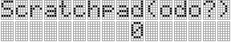
Description

Lcd Screens
Metric system | US system
Instrument
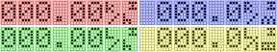 | 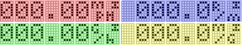
Description | Description
Description | Description
Description | Description
Description | Description
Custom
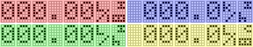 | 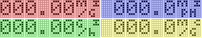
Description | Description
Description | Description
Description | Description
Description | Description
Pressures
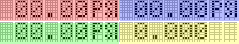
Description

Description

Description

Description

Voltages
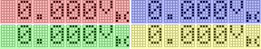
Description

Description

Description

Description

Instant / Current
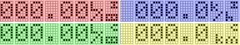 | 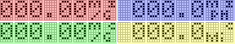
Description | Description
Description | Description
Description | Description
Description | Description
Instant / Tank
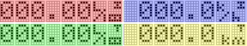 | 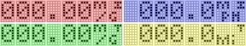
Description | Description
Description | Description
Description | Description
Description | Description
Current
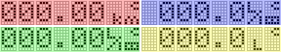 | 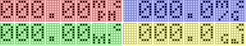
Description | Description
Description | Description
Description | Description
Description | Description
Tank
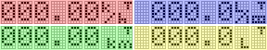 | 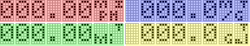
Description | Description
Description | Description
Description | Description
Description | Description
EOC / Idle
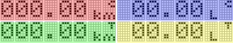 | 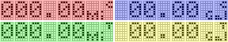
Description | Description
Description | Description
Description | Description
Description | Description
Tank Data
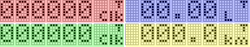 | 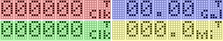
Description | Description
Description | Description
Description | Description
Description | Description
Current Data
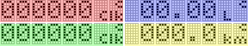 | 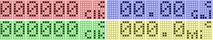
Description | Description
Description | Description
Description | Description
Description | Description
Tank EOC / Idle
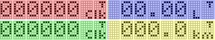 | 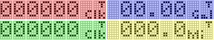
Description | Description
Description | Description
Description | Description
Description | Description
Current EOC / Idle
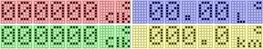 | 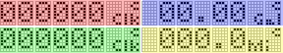
Description | Description
Description | Description
Description | Description
Description | Description
Remaining
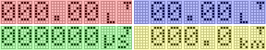 | 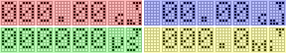
Description | Description
Description | Description
Description | Description
Description | Description
INST Fuel Econ
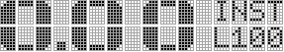 | 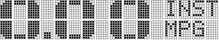
Description | Description
Curr Fuel Econ
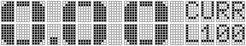 | 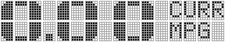
Description | Description
Tank Fuel Econ
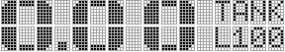 | 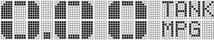
Description | Description
Memory
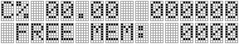
Description

DiffFE / Time
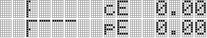
Description

FE / Time
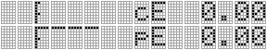
Description

FE / Speed
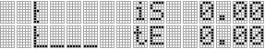
Description

Fuel Used / Speed
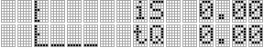
Description

RunTime / Speed
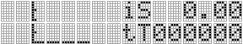
Description

Distance / Speed
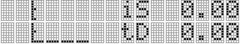
Description

INST Dist To Empty
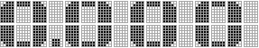
Description

CURR Dist To Empty
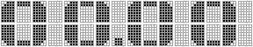
Description

TANK Dist To Empty
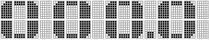
Description

INST Time To Empty
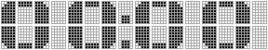
Description

CURR Time To Empty

Description

TANK Time To Empty

Description

System Time

Description

